1. Login Page:

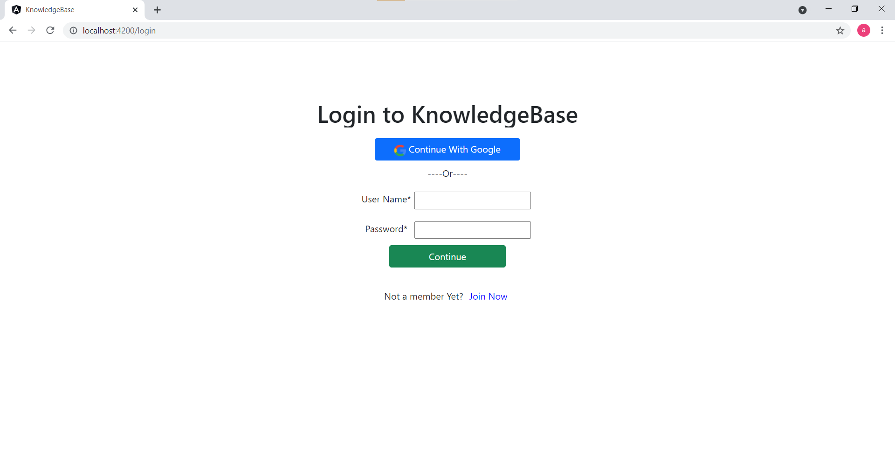

Registered Users can enter Username and Password/ Or continue with google account.

New Users can click on the ‘Join Now’ link.

1. Registration

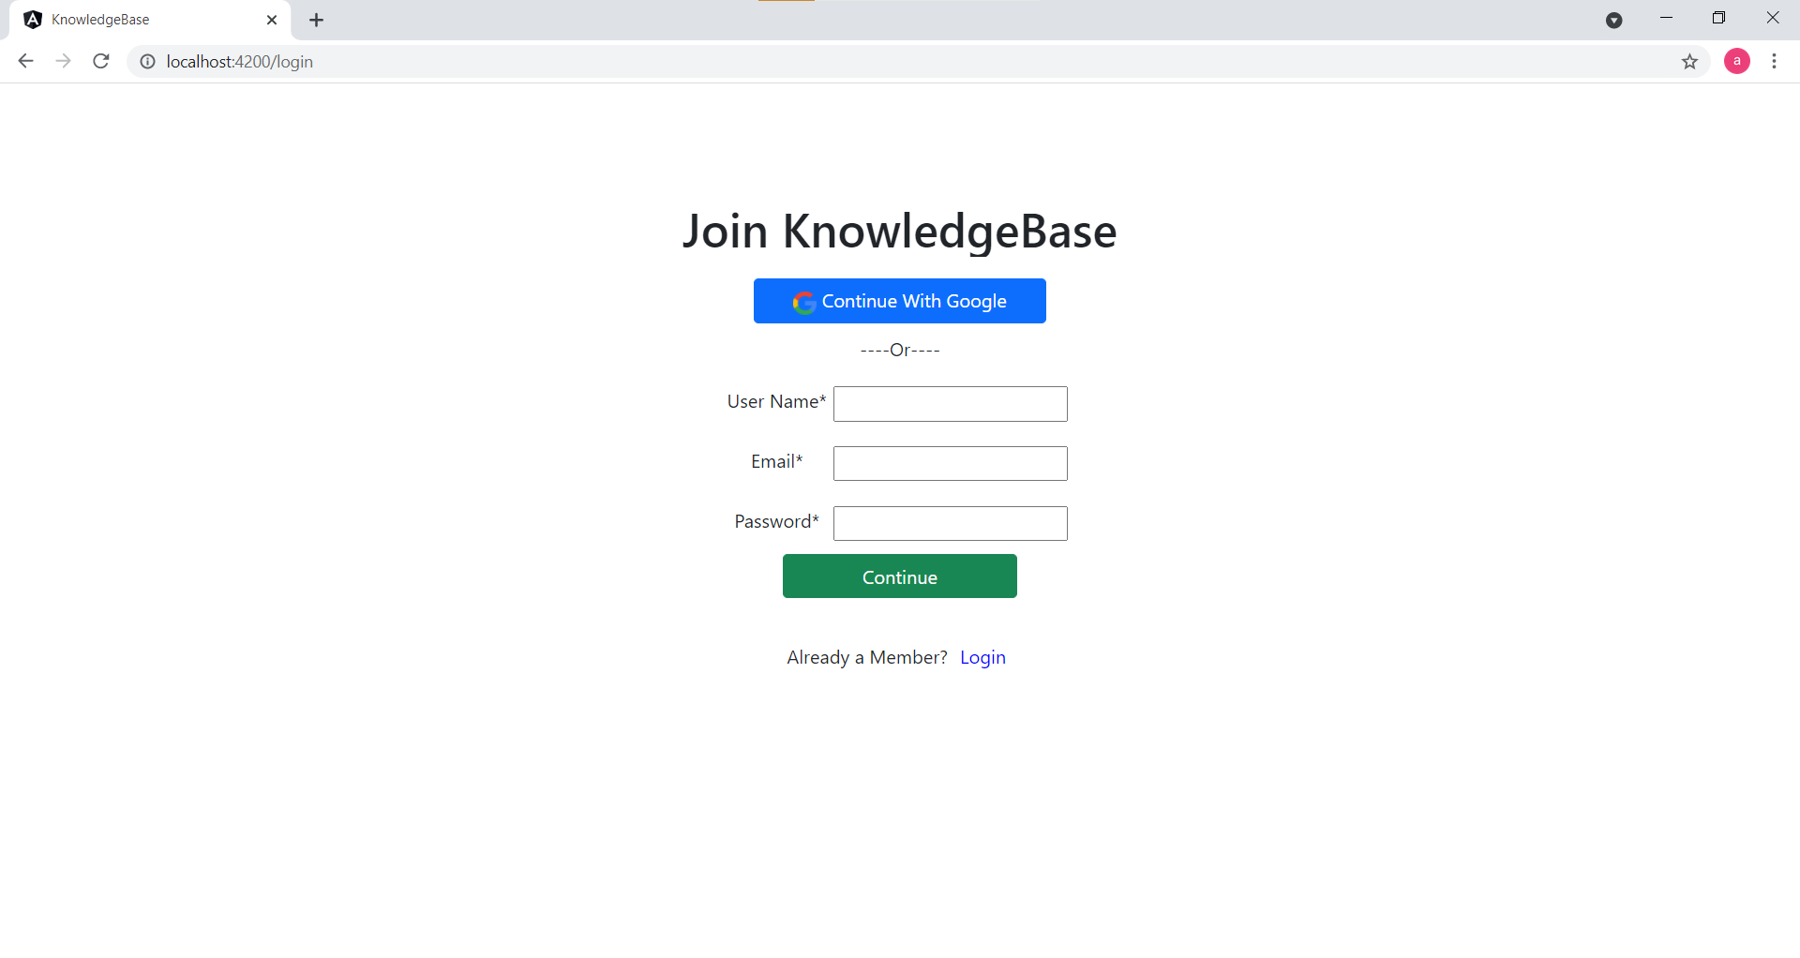

User can give proper Username , Email and Password or register him/her self with google account.

1. Knowledge Base Home Page:

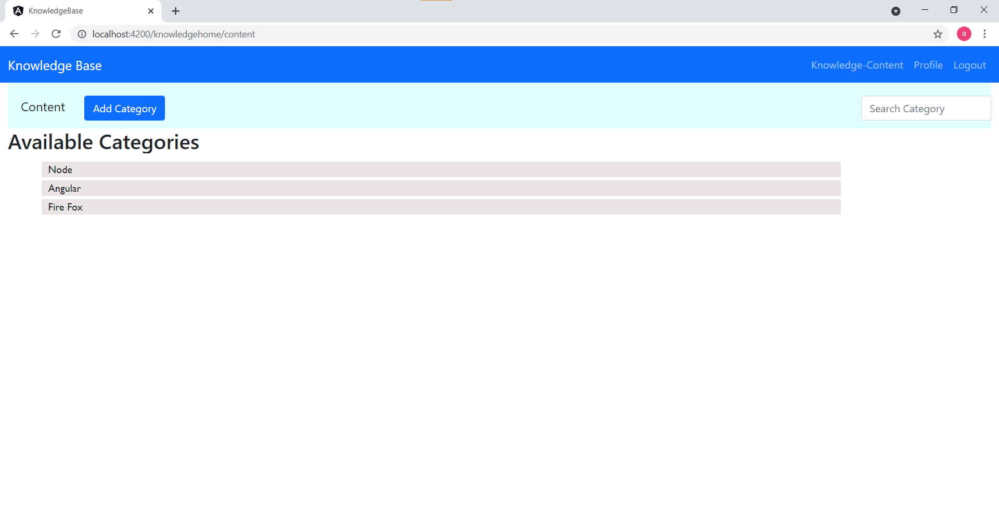

It will shows the Available Category for logged in User.

From navigation bar, user can see profile (Profile link), go to home page (Knowledge-Content link), logout from the application (Logout link) .

User can click on ‘Add Category’ button to add category, when clicked it will show below screen to enter data.

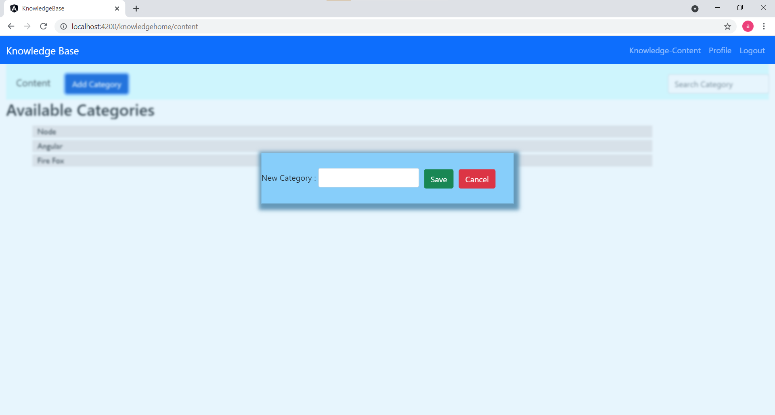

User can filter categories by writing the category name in the ‘Search category’ text box. (searching is case-insensitive)

When user clicks on any available Category, it will show the screen below.

1. Files:

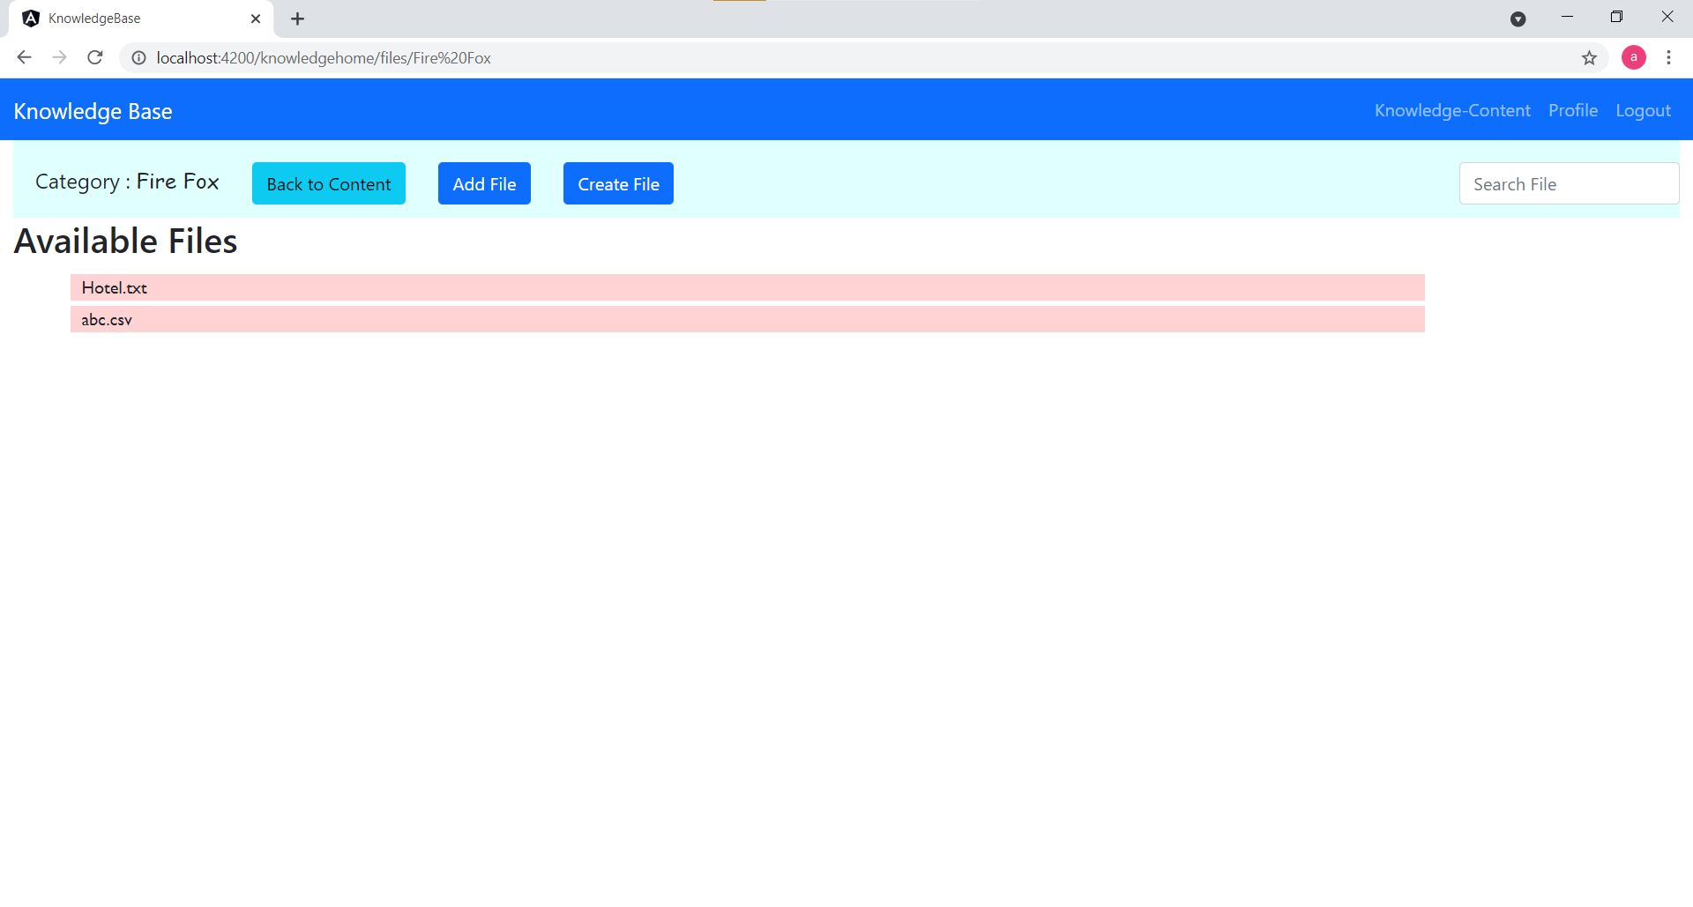

It will show available files for selected category

When users click on any file it will download that file to user’s machine.

User can filter files by writing the file name in ‘Search File’ text box. (searching is case-insensitive)

Users can go back to Categories by clicking on ‘Back to Content’ button.

Users can add file, by clicking on ‘Add File’ button. It will show below screen. Users can select file and upload it.

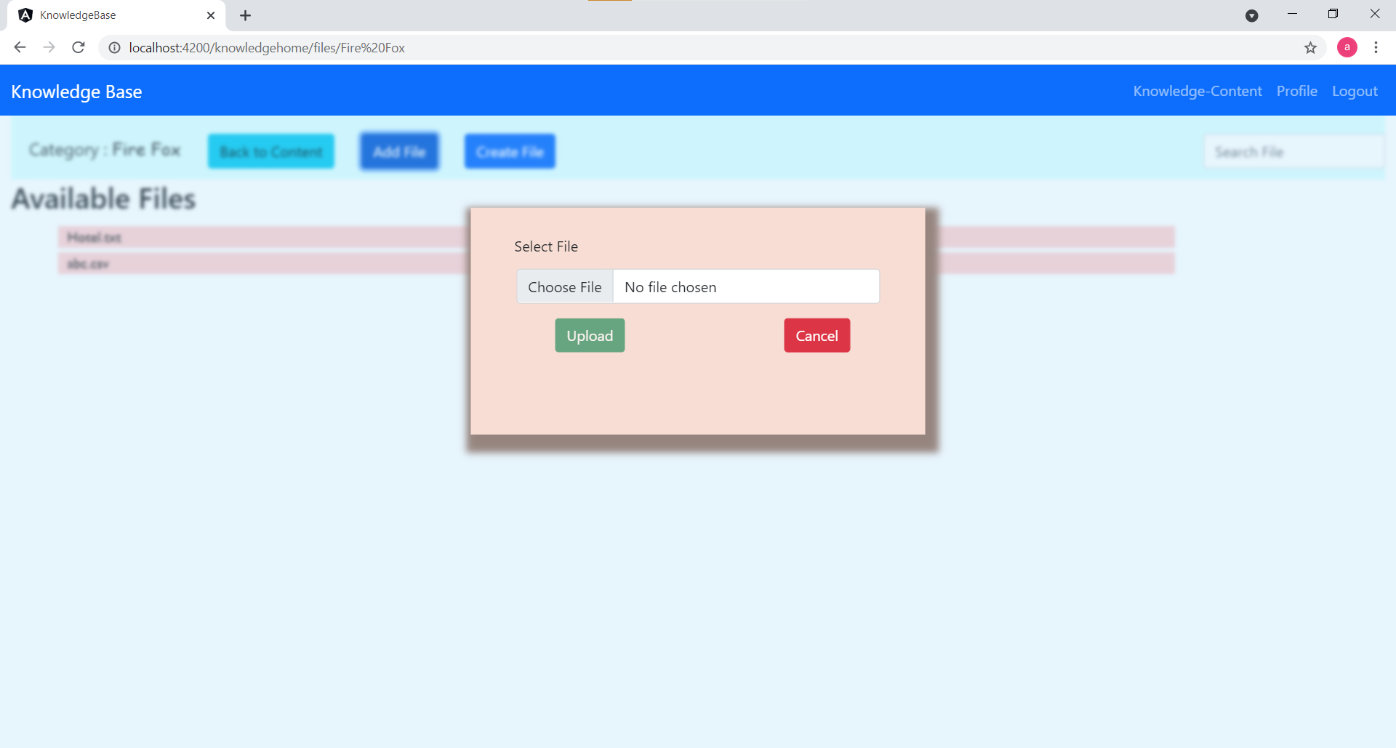

On Files-page, Users can create file by clicking ‘Create File’ button. It will show below screen. After giving details user can save file.

